Chapter 6
Randomized Block Designs for Development Research

The randomized block design, which is also called the multisite design arises when assignment to treatments is made within statistical clusters or blocks such as schools or classrooms (see, e.g., Kirk, 1995). It also arises when individuals are matched into groups by covariates such as social class or prior achievement and assignment to treatments is made within these matched groups. This design can be considerably more sensitive than the individually randomized design if the individuals within blocks are mor like one another (in terms of outcome scores) than they are to individuals in other blocks.
This design involves what might be conceived as a two-stage cluster sample, but it is handled in a special way. In the randomized block design, assignments to treatment are made within clusters, so that if clusters are schools, every school includes some individuals assigned to treatment and some to the control condition. The most obvious implementation of this design would be one in which individual students are assigned to treatments within schools, but it could also be implemented by assigning some students in each classroom to each treatment in each school.

Layout of the Design
The term “block” (sometimes called plot) in experimental design comes from the origin of experimental designs in agriculture, where field experiments were literally conduced in agricultural fields and blocks or plots were literally plots of ground within those fields. The layout of the design is a diagram of how the field might be divided into plots within those fields. Figure 1 illustrates the layout of a randomized block design, with shaded areas corresponding to treated portion of the blocks and unshaded portions of blocks corresponding to control portions of blocks. Note that the spaces between the blocks are intended to convey that the blocks (plots of land) might be physically distant from one another to ensure independence.
Insert Figure 1 About Here
In agriculture, there are variations in outcomes due to micro-variations in characteristics such as soil fertility, drainage, and temperature. These characteristics are related physical proximity and the physical proximity of the points where observations are taken within blocks assures that observations within blocks are likely to be more similar than they are to observations from different blocks. Thus observations within blocks are matched to one another.
In an educational field study, the ideas of layout and blocks are metaphorical rather than physical, but the same concept of matching applies. Individuals within blocks (e.g., schools) are likely to be more similar than individuals in different blocks, thus assignment to treatments within blocks is a kind of assignment among individuals who are matched to one another by virtue of being in the same blocks.

Statistical Model and Notation
Suppose that the design has m blocks, and the n individuals in each block are randomly assigned to each of the treatment and the control condition. Such a design is called a balanced design because there are equal numbers of individuals assigned to each treatment within each block. Balanced designs are desirable because they are the most sensitive, that is they produce statistical tests that have the highest statistical power and the most precise estimate of treatment effects for a given sample size. Then, in the conventional notation of the analysis of variance, the model for Y_{ijk}, the outcome measurement of the k^{th} individual in the j^{th} block and the i^{th} treatment, is
Y_{ijk} = μ + α_{i} + β_{j} + αβ_{ij} + ε_{ijk}, i = 1, 2; j = 1, …, m; k = 1, …, n, (1)
where μ is the grand mean, α_{i} is the effect of the i^{th} treatment, β_{j} is the effect of the j^{th} block, αβ_{ij} is the interaction effect of the i^{th} treatment and the j^{th} block, and ε_{ijk} is a residual. The residual ε_{ijk} is assumed to have a normal distribution with variance σ_{ε}² and the grand mean μ and the treatment effects α_{i} are taken to be fixed, but unknown constants.
Let(j = 1, …, m) and (j = 1, …, m) be the means at the j^{jh} block in the treatment and control groups, respectively, letand be the overall (group) means in the treatment and control groups, respectively, and letbe the grand mean. This notation with dots in the subscripts may seem confusing, but it has a logic. It takes the values of all three subscripts to identify a particular observation, but one could average over all observations in treatment group 1 to obtain (here that average is denoted by dots in the second and third subscripts which identify the block and individual within block within treatment group to denote averaging over individuals and blocks). Alternatively, one could average over only the observations in treatment group 2 within block j to obtain (here the dot appears only in the third subscript to denote averaging only over individuals).

How the Randomized Block Design Increases Precision
Precision of treatment effect estimates is best understood in terms of what counts as “error” or imprecision. Imprecision is all the variation within treatment groups. This is the “noise” that statistical tests compare to the signal of treatment effects to see if the treatment effects are big enough to be reliable (i.e., statistically significant). If we just assign individuals to treatments ignoring the blocks, variation across blocks is part of the imprecision. The randomized block design makes treatment-control comparisons between individuals in the same block (and then averages these block-specific treatment effects across blocks). Therefore, variation across blocks is not part of the imprecision in the randomized block design. Because there are typically differences between average scores across blocks, randomized block designs have smaller amounts of imprecision and yield more precise estimates of treatment effects than do designs that do not match within blocks.

Fixed Versus Random Block Effects
An important distinction in experimental design is whether to conceive effects as being fixed or random. This distinction has a variety of general ramifications but one that matters for the randomized block design is how statistical (as opposed to substantive) inference is used in the logic of inference from the study. Two different possibilities conform to the blocks fixed and blocks random distinction.
Blocks fixed. One possibility (the blocks fixed model) is that the statistical inference is to the treatment effect in the blocks that are actually in the experiment. In this case, we might say that the statistical inference is to the average treatment effect in these blocks. Inference to other blocks not in the experiment is an extra-statistical matter that depends on substantive issues, such as whether the target of generalization sufficiently similar to the experiment that generalization is reasonable. Statistical inference can assess the uncertainty in inference about whether there was a treatment effect in the blocks observed in the experiment but not the uncertainty associated with the similarity (or not) of application of treatment effects to blocks not in the experiment.
Blocks random. A more complex possibility (the blocks random model) is that the blocks in the experiment are conceived as a random sample from a population of blocks and that inference is intended to be to that population of blocks (most of which are unobserved). In this case, the statistical inference is about the treatment effect in that universe of blocks (e.g., to the average treatment effect in that population of blocks). This model is appealing because it invokes the sampling theory of generalization to explain why results of this experiment generalize to other blocks. However, the blocks in field experiments are seldom chosen by random sampling. Thus, researchers making inferences are faced with the question of “from what population of blocks could those in the sample have possibly been a random sample?” This is an extra-statistical mater that depends on substantive considerations much like those in the blocks fixed model.
Choosing between the blocks fixed and blocks random models. The blocks fixed model is simpler both conceptually and statistically. In many initial field trials undertaken as part of intervention development, the primary question is whether the intervention can produce an effect under favorable circumstances. This is in contrast with the efficacy and effectiveness questions of whether the intervention can produce effects in typical circumstances or whether it can be made to work at scale. Thus, the blocks fixed model often appropriate for initial field trials. For that reason, we focus the bulk of our attention on the blocks fixed model in this paper.
The blocks random model stretches statistical inference to accomplish a more demanding goal of assessing generalizability to a larger population of blocks rather than just inferring to the observed blocks. Consequently, designs with more blocks and larger sample sizes are typically required to achieve adequate sensitivity in the blocks random model. The blocks random model is often more appropriate when the inference goal is to understand what the intervention effect might be when it is scaled up to a much larger implementation (but attention to the sampling of blocks is important to support such inferences).

The Statistical Analysis of Randomized Block Designs

In any analysis of the randomized block design, it is important to recognize that it is possible to estimate the treatment effect within each block. For example, the treatment effect estimate for the j^{th} block is
, j = 1, …, m.
Regardless of whether blocks are fixed or random, the overall treatment effect estimate is the average of the block-specific treatment effect estimates
and if (as in our model) the design is balanced
.
The statistical tests for treatment effects differ somewhat depending on whether blocks are fixed or random.
Blocks fixed. If blocks are fixed, then the test statistic used for testing treatment effects is
F = MSA/MSW,
where MSA is the so-called treatment mean square defined by
,
and MSW is the so-called within cells mean square defined by
(see, e.g., Kirk, 1995). When the null hypothesis of no treatment effects is true, the test statistic has the F-distribution with 1 degree of freedom in the numerator and N – 2m degrees of freedom in the denominator. Thus we carry out the significance test by comparing the obtained value of F with the appropriate critical value of the F-distribution with 1 and N – 2m degrees of freedom or by using the p-value computed by the analysis software.
The standard error (precision) of the treatment effect estimate is
.
Blocks random. If blocks are random, then the test statistic used for testing treatment effects is
F = MSA/MSAB,
where MSA is the so-called treatment mean square defined above and MSAB is the so-called block-treatment interaction mean square defined by
(see, e.g., Kirk, 1995). When the null hypothesis of no treatment effects is true, the test statistic has the F-distribution with 1 degree of freedom in the numerator and m – 1 degrees of freedom in the denominator. Thus we carry out the significance test by comparing the obtained value of F with the appropriate critical value of the F-distribution with 1 and m – 1 degrees of freedom or by using the p-value computed by the analysis software.
The standard error (precision) of the treatment effect estimate in the blocks random model is
.
Comparing blocks fixed and blocks random analyses. The number of degrees of freedom in the denominator is smaller in the blocks random model than in the blocks fixed model [(m – 1) versus (N – 2m)]. Because the critical values are an increasing function of denominator degrees of freedom, this means that the critical values are larger for the blocks random test than the blocks fixed test. Also, there is a factor on n in MSAB that tends to make it larger than MSE, so that MSAB is typically larger than MSW. Thus the blocks random test statistic tends to be smaller (because it has a larger denominator) but requires a larger value to be declared statistically significant (because the critical value is lager), so the blocks random test tends to be less sensitive than the blocks fixed test.
Note that the blocks random test statistic uses the same numerator (MSA) but a different denominator (MSAB versus MSW) than the blocks fixed test statistic. Examining the formula for MSAB, notice that MSAB is actually the n/2 times the sum of squared differences of the block specific treatment effects, thevalues from the average treatment effect, divided by m – 1. That is, MSAB is n/2 times the variance of thevalues. Another way of writing the F-statistic is that it is the square of the one-sample t-statistic applied to the block-specific treatment effect estimates
,
whereis the standard deviation of the block-specific treatment effect estimates.
Because SE_{F} and SE_{R} differ in that SE_{F} is computed using MSW and SE_{R} is computed using MSAB, and because MSAB tends to be larger than MSW, it follows that SE_{R} is typically larger than SE_{F}.
The fact that the blocks random model produces less sensitive tests and less precise estimates is not a paradox. These differences stem from the differences in the statistical inferences each model is trying to support. In the case of the blocks fixed model, inferences are about the specific blocks that are observed. This is an “easier” inference that the inferences to a larger population of blocks that the blocks random model is trying to accomplish.
Unbalanced designs. The statistical analysis methods we described above apply to balanced designs. The extension of these methods to unbalanced designs is rather straightforward in the blocks fixed model. Let n_{ij} refer to the sample size in the ith treatment group in the jth block. In that case, the test statistic is
F = MST/MSE,
where
,
,
and
.
Here the test statistic has 1 degree of freedom in the numerator and N – 2m degrees of freedom in the denominator. Thus we carry out the significance test by comparing the obtained value of F with the appropriate critical value of the F-distribution with 1 and N – 2m degrees of freedom or by using the p-value computed by the analysis software.
The precision of the treatment effect estimate in the unbalanced blocks fixed analysis is
.
The analysis of unbalanced design if the blocks random case is more complex. The simplest and most flexible analyses are probably accomplished using hierarchical linear models (see, e.g., Raudenbush and Bryk, 2002).

Planning Randomized Block Designs with Fixed Block Effects

The object planning a research design is to ensure that if the data is collected according to the design, the analysis of that data will yield unambiguous results. To ensure results will be unambiguous, the design has to be sufficiently sensitive. There are three different, but complementary, ways to describe design sensitivity, all of which can be useful in planning designs.
One way to describe design sensitivity is statistical power. Statistical power is the chance that if there is a (true or underlying) intervention effect of a given size, the statistical analysis is likely to detect it. Statistical power analysis starts with the size of an effect that is deemed important enough to detect, and a design (e.g., a sample size configuration), and describes the probability that an effect of the given size would result in a statistically significant observed effect. Computation of statistical power can be accomplished by suing tables of power values, but is more easily accomplished using specialized software
Another way to describe design sensitivity is the use of minimal detectable effect size. The minimal detectable effect size is the smallest effect size for which the design has a given statistical power. Using this approach, one starts with design (a sample size configuration) and a desired level of statistical power and describes the smallest effect size for which the design has the specified level of statistical power. Approximate computations of minimum detectable effect size can be done using tables, but exact computations of require specialized software.
A third way to describe design sensitivity is precision. Precision is the standard error of the estimated treatment effect, which determines the width of the confidence interval for the treatment effect. Using precision analysis, one starts with the design (a sample size configuration) and computes the precision that would be expected.

General Principles for Planning Randomized Block Designs with Fixed Block Effects
Planning a randomized block design with fixed block effects to evaluate an educational intervention primarily involves choosing a design that will have adequate sensitivity (high statistical power and precision, or small minimal detectable effect size). In principle, design sensitivity depends on the significance level chosen, the effect size expected, m, and n. Although significance level is in principle an arbitrary choice of the investigator, the 0.05 or 5% significance level has been so reified by convention that it is, for all practical purposes, not a choice but the de facto standard. The effect size expected is also not completely a choice but is dictated by the prior experience of the investigator about what size effect is large enough to be important or is the effect size to be expected from the intervention being evaluated. Thus, planning the design amounts to deciding on how many blocks or sites (which are typically schools) and how many subjects (usually students) to assign to each treatment within each block. That is, planning the design involves choosing m and n to achieve the desired design sensitivity.
The computation of either statistical power or minimum detectable effect size can be accomplished by using statistical tables that are widely available (see, e.g., Hedges and Rhoads, 2009) or by the use of statistical software that can compute noncentral F-distribution function (see the Appendix). It is probably easiest to use software that is designed to do the computations directly (e.g., Website reference). While exact power computations using software are recommended, we offer a few general principles that are helpful in the sections that follow and illustrate them with computations of design sensitivity.

Sensitivity Depends Mostly on δ, and N = 2mn, Very Little on m or n or Fixed N
The most sensitive design given a fixed total sample size N is a balanced design in which the same number of individuals are assigned to each treatment within each block. Exact design sensitivity depends on m, n, and δ, but in balanced designs, sensitivity essentially depends only on the total sample size N in balanced designs. Table 1 shows the statistical power, minimum detectable effect size, and standard error of the estimated treatment effect for a fixed total sample size of N = 400 and effect size values of δ = 0.20, 0.25, and 0.30. The table shows that the minimum detectable effect size and standard error of the treatment effect estimate are the same (to two decimal places) whether m = 2 and n =100 or m = 100 and n = 2 (or any values in between where 2mn = 400). For a given effect size δ, values of statistical power differ only in the third decimal place.

Insert Table 1 About here
There is one other pattern in the table that is worth noting. Both the minimum detectable effect size and the standard error of the estimated treatment effect are the same for all three values of δ. This is because neither depends on δ. For example, the minimum detectable effect size describes the smallest effect the design could detect (with, e.g., 80% power) and does not presuppose any specific effect size. Similarly, the calculation
The reason sensitivity depends primarily on N and not m or n individually, is that statistical power depends on the so-called noncentrality parameter
and, to a lesser extent, on the degrees of freedom of the test f = N – 2m (see the Appendix). Because the noncentrality parameter is constant for fixed N, only the degrees of freedom change with m and n. When N is large enough, the degrees of freedom remain relatively large regardless of the size of m and have relatively little effect on power.
The fact that power depends mainly on total sample size means that the researcher is free to use any design that has sufficient sample size to obtain the power that they require. There is a convention in social sciences that power of 80% or better is desirable. Thus, the researcher may choose a design that produces 80% power by finding the total sample size N that leads to 80% power for the effect size they wish to detect.
Equivalently, they could find a total sample size N that has a minimal detectable effect size (at 80% power) as small or smaller than the effect size they wish to detect. Figure 1 gives the minimal detectable effect size as a function of total sample size N (for m = 10 blocks, but results would be virtually identical for other values of m). One important thing this figure reveals is that adequate power can be achieved with a balanced design of 5 to 10 blocks (schools) so long as there is an adequate total sample size. Specifically to obtain 80% power to detect effect sizes of δ = 0.2, a total sample size of 760 is needed, to detect an effect size of δ = 0.25, a total sample size of N = 500 is needed, and to detect an effect size of δ = 0.30 a total sample size of N = 340 is needed.

Insert Figure 1 About Here

Once the total sample size is determined, there is the choice of how many blocks and how many individuals to assign to each treatment within each block (in other words, the choice of m and n so that 2mn = N). Because this choice does not affect design sensitivity, it must be made on other considerations. An obvious consideration is practical: It is usually more difficult to carry out a study in a larger number of schools (if schools are blocks) than a smaller number. There is however another consideration: Generalizibilty (sometimes called external validity). Because this is an extra-statistical consideration when block effects are fixed, it cannot be addressed technically, but it is none the less important. The larger the number of schools, the greater the presumed generalizability of the results. The choice of a design must reconcile these two opposing considerations.

Using Covariates Can Increase Sensitivity and reduce Sample Size Requirements
Covariates are any variables whose value could not have been influenced by the treatment assignment. The most common covariates are baseline data (such as pretests) collected before the treatment begins. If baseline data on individuals is available, it can be used to increase the sensitivity of the design if the analysis uses statistical adjustment via regression or the analysis of covariance. The use of a covariate (or multiple covariates) essentially has the same impact as increasing the effect size. In particular, if the effect size (with no covariates used) is δ and correlation (or multiple correlation if there is more than one covariate) between the covariate(s) and outcome is ρ, then the design using covariates is roughly equivalent to increasing the effect size from δ to. This is generally an increase because 0 ≤| ρ| ≤ 1, which implies that.
Figure 2 gives the minimal detectable effect size as a function of total sample size N (for m = 10 blocks, but results would be virtually identical for other values of m) for four values of ρ. The solid line reflects no covariates (ρ = 0), the dashed line reflects ρ = 0.4, the dotted line reflects ρ = 0.6, and the final line (which is dotted and dashed) reflects ρ = 0.7. The dashed line is somewhat lower than the solid line reflecting that the minimum detected effect size is somewhat smaller when using a covariate with a correlation of ρ = 0.4 with the outcome. For example, when ρ = 0.4, a sample size of only N = 320 is needed to detect and effect of δ = 0.30, but with no covariates a sample size of N = 340 is needed. The impact of a covariate with a correlation of ρ = 0.6 is somewhat larger. For example, a sample size of only N = 400 inC <- s needed to detect an effect of δ = 0.2 using a covariate of ρ = 0.6, but with no covariates, a sample size of N = 500 is needed.

Insert Figure 2 About Here

While covariates add complexity to the analysis, they can substantially increase design sensitivity and reduce sample size requirements. Pretests of measures similar to the outcome are often the most effective covariates (the ones with the largest correlations with the outcome). Note that cognitive tests tend to be rather highly correlated with one another, so it is not essential that the covariate measure exactly the same construct as the outcome to be useful. For example, reading achievement tests may be useful covariates, even in studies using math or science achievement as the outcome, outcome. Other variables measured at baseline (such as race or social class measures are typically poorer covariates (see Hedberg and Hedges, 2007).

Unequal Allocation to Treatments Can Have Advantages if it Enables Larger N
For a fixed total sample size N, a balanced design (equal allocation of individuals to treatment and control in each block) is the most sensitive (with or without covariates). However, there are situations in which the sample size is limited by the number of individuals who can be treated. For example, there may only be enough field staff to work with a limited number of treatment teachers or there may be a limited number of computers or other technology necessary to use the intervention. In that case, unequal allocation of individuals to treatment groups (more individuals randomized to control and fewer to treatment) can increase the total sample size and can increase design sensitivity.
Suppose that an unbalanced design assigns n^{T} individuals to treatment in each block and n^{C} individuals to control in each block so that the proportion π = n^{T}/(n^{T} + n^{C}) of individuals in each block are assigned to treatment and a total of N^{T} = Nπ individuals are assigned to treatment overall. In a balanced design the total sample size would be N = n^{T}/0.5 = 2n^{T}, but in an unbalanced design, because π < 0.5, the total sample size N would be greater than 2n^{T}. In fact, the ratio of the total sample size of a design with π = N^{T}/N to that of the balance design would be 1/2π. Thus if π = 0.5 (the design is balanced) the ratio is unity, as expected ,but if π = 0.4, the total sample size of the design is 25% larger, if π = 0.3 it is 67% larger, and if π = 0.2 it is 150% larger than that of a balanced design with the same number of treated individuals. This increased total sample size increases design sensitivity.
While imbalance of the design does not literally change the effect size, it has an effect on sensitivity that is equivalent of changing the effect size from δ to. Because
and only equal to δ if π = 0.5, imbalance has a tendency to increase sensitivity because of the increased total sample size, but a simultaneous tendency to decrease sensitivity because it does the equivalent of decreasing the effect size. However, unless π is very much smaller than 0.5, the positive impact of imbalance on total sample size is bigger than the negative impact on effect size and the unbalanced design is more sensitive with the same number of treated individuals.
Figure 3 shows the minimum detectable effect size as a function of the total number of individuals assigned to treatment for balanced designs (π = 0.5) and unbalanced designs with various degrees of imbalance (π < 0.5). For example, if N^{T} = 250 individuals are to be treated, a balanced design would have a minimum detectable effect size of δ = 0.25, but that could be reduced to δ = 0.21 if we assigned π = 0.3 (30%) of the total individuals to treatment. This would mean assigning N^{T} = 250 individuals to treatment and N^{C} = 583 for a total sample size of N = 833. We could lower the minimum detectable effect size to δ = 0.20 by using an even more imbalanced design and assigning π = 0.2 (20%) of the total individuals to treatment. In this case N^{T} = 250 individuals would still be assigned to treatment, but N^{C} = 1,000 individuals would have to be assigned to the control group, for a total sample size of N = 1,250.

Insert Figure 3 About Here

While greater sensitivity (for a fixed number of treated individuals) can be achieved with highly imbalanced designs, such designs necessarily involve larger sample sizes than balanced designs achieving the same sensitivity. For example, a balanced design with no covariates and a total sample size of N = 760 could achieve the same sensitivity (MDES = 0.21) as the unbalanced design with a total sample size of N = 1,250. The balanced design would need to treat 110 more individuals (for a total of N^{T} = 380), but would need 620 fewer individuals in the control group (N^{C} = 380 instead of 1,000). If the capacity to treat individuals is limited by cost or other considerations and the capacity of the control group is not, the unbalanced design might be a good design choice.
There is not always unlimited capacity to include individuals in the control group. If, for example, instructional or other conditions in the control group are monitored as part of the experiment, or if the cost of assessment of control individuals is high (e.g., if individually administered assessments are used), there can be significant costs involved with the control group. In such cases the financial and practical cost of obtaining the required sample size by adding individuals to the control group will need to be balanced by the costs of adding individuals to the treatment group will have to be balanced against one another.
While small degrees of imbalance are unlikely to be apparent, there may be political considerations in using highly unbalanced designs. For example, if the blocks are schools, it may be difficult for school personnel to justify participating in an experiment in which very few students in the school actually receive the treatment. Depending on the details of the treatment, there may also be practical difficulties in implementing a treatment if too few individuals are assigned to receive it at each site.
On the other hand, there may be situations that are well suited to a highly imbalanced design. For example, if the treatment seems highly desirable and can be individually administered (e.g., an expensive stand-alone technology intervention), a design offering a lottery for a very few lucky students to receive the treatment (with an understanding that most would not be able receive it) might be a very attractive design if the outcome was easy to measure (e.g., from data already collected by the schools).

Planning Randomized Block Designs with Random Block Effects

It is much more complex to plan randomized block designs with random block effects than to plan those with fixed block effects. Sensitivity in these designs is not primarily a function of total sample size and effect size, but depends importantly on both the number of blocks and the number of individuals within the blocks. Sensitivity also depends on the degree of treatment effect heterogeneity across blocks, something that is difficult to know in advance. Because of these difficulties, a complete treatment of planning designs with random block effects is beyond the scope of this paper. However, some generalizations are possible.
In general, randomized block designs with random block effects will require larger sample sizes than designs with fixed block effects to obtain the same sensitivity to detect a given effect size δ. Designs with random block effects will usually require a minimum number of blocks (e.g., more than 5 – 10 blocks) to achieve adequate sensitivity to detect all but very large effects. If a great deal of treatment effect heterogeneity is expected, designs with random block effects will require large numbers of blocks to obtain high sensitivity.
This brief discussion is not intended to be an argument that designs with random block effects have few virtues. Recall the discussion of the logic of generalization from designs with random block effects. These designs are intended to incorporate into their statistical inference, the uncertainty associated with generalization to a population of other blocks (most of which are not observed). The penalty for that more expansive role for statistical inference is greater complexity and more extensive sample size requirements.

Examples
Conclusions

Randomized block designs with fixed block effects can powerful research designs that are scientifically rigorous, but are often quite feasible and straightforward to plan and to use in evaluation designs. They are often implemented with schools taking the role of blocks, and designs with as few as 5 – 10 blocks can be sensitive enough to detect modest effects of treatments. Sensitivity can be increased by the use of covariates like pretests, but this modestly increases the complexity of the statistical analyses. While balanced designs provide the greatest sensitivity for a fixed total sample size, unbalanced designs can achieve greater sensitivity in cases where the treatment can only be administered to a limited number of individuals, but a larger number of control individuals can be handled.

References
American Educational Research Association. (2006). Standards for reporting on empirical social science research in AERA publications. Educational Researcher, 35, 33 –40. https://doi. org/10.3102/0013189X035006033
Bloom, H. S. (1995). Minimum detectable effects: A simple way to report the statistical power of experimental designs. Evaluation Review, 19, 547-556.
Donner, A. & Klar, N. (2000). Design and analysis of cluster randomization in health research. London: Arnold.
Fisher, R. A. (1935).
Hedges, L. V. & Hedberg, E. C. (2007). Intraclass correlations for planning group-randomized experiments in education. Educational Evaluation and Policy Analysis, 29, 60-87.
Hedges, L. V. and Rhoads, C. (2009). Statistical Power Analysis in Education Research (NCSER 2010-3006). Washington, DC: National Center for Special Education Research, Institute of Education Sciences, U.S. Department of Education.
Hocking, R. R. (1973). A discussion of the two-way mixed model. The American Statistician, 24(4), 148-152.
Kirk, R. (1995). Experimental design (3rd Edition). Belmont, CA: Brooks Cole.
Lind, J. (1753). A treatise on scurvy. Edinburgh: Sands, Murrray, and Cochran.
Raudenbush, S. W., & Bryk, A. S. (2002). Hierarchical linear models. Thousand Oaks, CA: Sage Publications.
Searle, S. R. (1971). Linear models. New York: John Wiley.
Shadish, W. R., Cook, T. D. & Campbell, D. T. (2002). Experimental and quasi-experimental designs for generalized causal inference. Boston: Houghton Mifflin.

Appendix
Power computations for this design are based on the sampling distribution of the F-statistic given in the text. When there is no block treatment interaction and δ² ≠ 0, then F has the
noncentral F-distribution with 2m(n – 1) degrees of freedom and noncentrality parameter
(see, e.g., Searle, 1971). Therefore, the statistical power of the level α test of the null hypothesis H₀: δ² = 0 is
G[c_{α}| λ, 2m(n– 1)]
where c_{α} is the 100(1 – α) percentile of the central F-distribution with 2m(n – 1) degrees of freedom and G[x | λ, ν] is the cumulative distribution function of the noncentral F-distribution with ν degrees of freedom and noncentrality parameter λ.
The approximate minimal detectable effect size can be obtained using a formulas in Bloom (1995) or by iteratively computing power with successively larger values of the effect size until the appropriate power is obtained.

Figure 1
Minimum detectable effect size as a function of total sample size N (with m = 10)
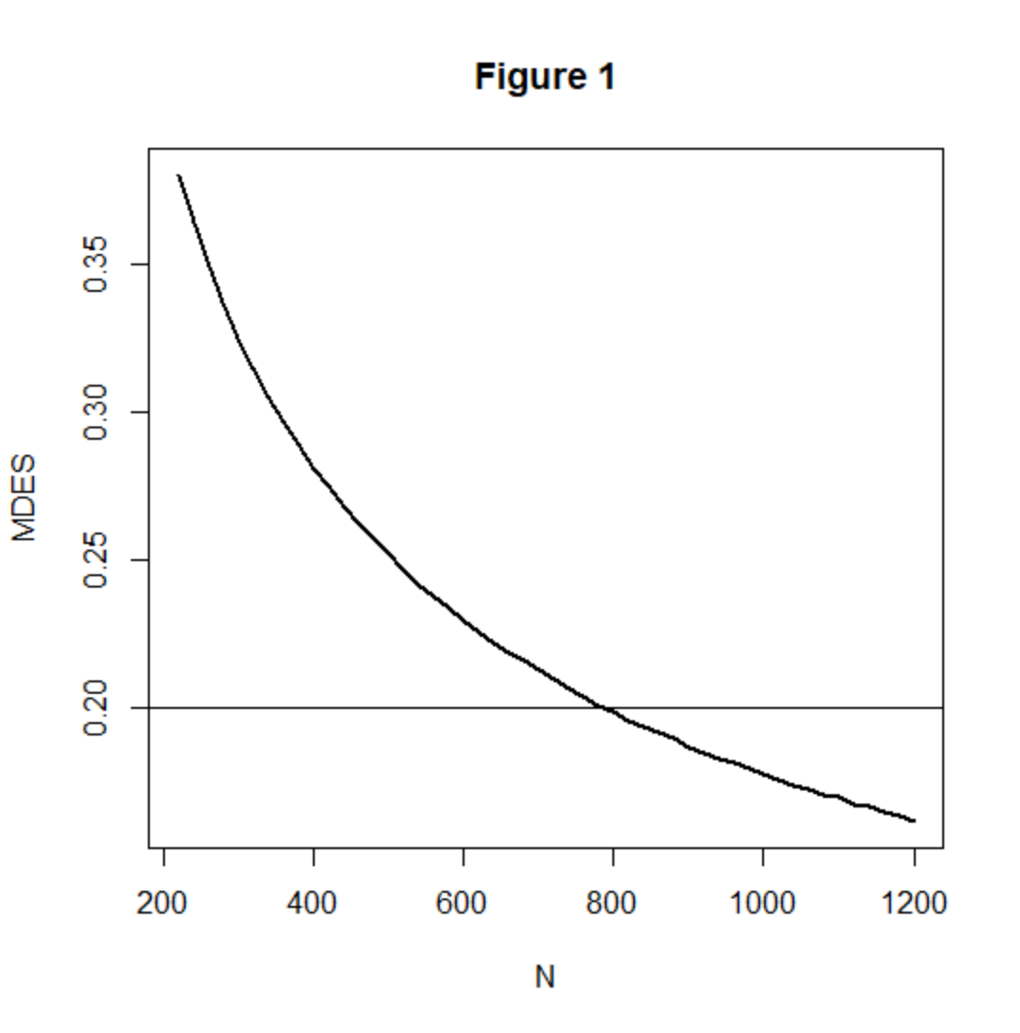

Figure 2
Minimum detectable effect size as a function of total sample size N (with m = 10), for ρ = 0 (no covariates, solid line), ρ = 0.4 (dashed line), ρ = 0.6 (dotted line), and ρ = 0.7 (dashed and dotted line).

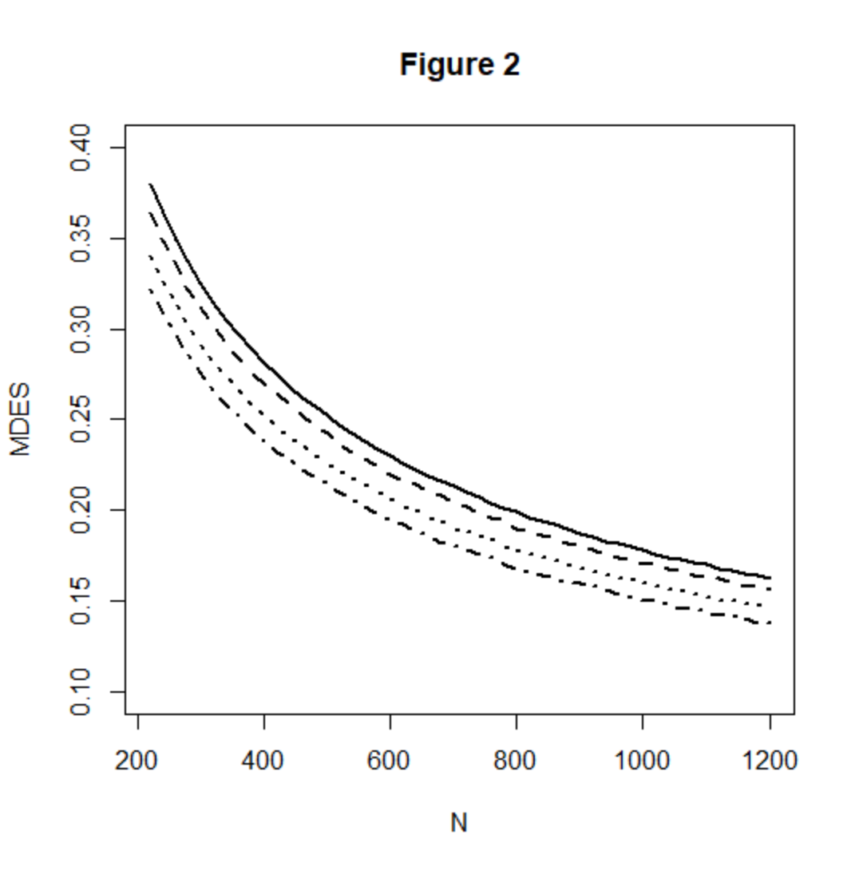

Figure 3
Minimum detectable effect size as a function of treatment group sample size n^{T}, when the treatment group is a proportion π =0.5 (solid line), π = 0.4 (dashed line), π = 0.3 (dotted line), π = 0.2 (dashed and dotted line), and π = 0.1 (long dashed line) of the total sample.
